This document is a template designed for use by Local Authorities and Utility companies to support the transition to Street Manager. It is intended to support internal business cases that might be needed in order to obtain financial and other resources. This template can be adapted and formatted as necessary.

Some sections and information will be more relevant for Local Authorities or Utility companies. Please delete as appropriate and add additional information from your own data as needed for your own approval processes.

It will also need to be updated, e.g. if you use this later in 2019.

Street Manager

Business Case

Created by:

Version:

Date:

Approved by:

Date Approved:

**Contents**

1. Introduction 4

1.1 Purpose of this Document 4

1.2 Background 4

1.3 The Beta development phase 7

1.4 The DfT’s requirements 8

1.5 Fit with wider strategic goals 8

2. Strategic Case 10

2.1 Strategic drivers for change 10

Benefits 12

2.2 Issues with existing arrangements 12

Consistency and standardisation: 13

Data transparency and accuracy 14

Speed and fluidity 14

Collaboration 14

Innovation 14

Data and technology 14

2.3 Business needs 15

Prioritised user needs 15

Key user personas 16

Additional user needs 17

2.4 Impact of not changing 18

2.5 Strategic options for delivery 18

2.6 Recommendation 19

2.7 Risks of strategic option 19

3. Economic Case 20

3.1 Economic options and costs 20

3.2 Cost of congestion from street works 20

3.3 Benefits identification 20

3.4 Value for Money 22

3.5 Limitations and Analytical Assurance 23

4 Commercial case 24

4.1 Required products and services 24

5 Financial case 25

5.1 Financial appraisal 25

5.2 Affordability 25

6 Management case 26

6.1 Timetable 26

6.2 Ongoing governance 26

6.3 Milestones 26

6.4 Key issues, risks and risk management 26

# Introduction

## 1.1 Purpose of this Document

This document presents a business case seeking approval to transition to using the Government’s new Street Manager digital service. The Department for Transport (DfT) is amending regulations that will require us to replace use of the existing Electronic Transfer of Notifications (EToN) system with Street Manager. The vision for the Street Manager service is to transform the planning, management and communication of street and road works through open data and intelligent services to minimise disruption and improve journeys for the public. It will be for registered users from local highway authorities and utility companies, and for contractors.

## Background

The current system used for managing street and road works were originally developed in the 1990s. Our use of this system as a way of communicating between local highway authorities and utility companies is mandated, most recently by the Street Works (Registers, Notices, Direction and Designations) (England) Regulations 2007 (the 2007 Regulations), and the Street Works (Charges for Unreasonably Prolonged Occupation of the Highway) (England) Regulations 2009 (the 2009 Charges Regulations). TheTraffic Management Permit Scheme (England) Regulations 2007(the 2007 Permit Regulations)also cover communications underpermit schemes.

The system is known as the Electronic Transfer of Notifications or EToN. The DfT owns and issues a detailed technical specification that provides the rules through which data is exchanged (an XML schema) between EToN systems. The data requirements and the technical specification are underpinned by regulations and associated guidance.

Each individual local authority, utility company and/or contractor has its own EToN product or software package that is provided by a small number of private sector companies. The technical specification has been updated over the years by the DfT. The last time was in 2013. EToN allows for the notices and permits that are needed for street and road works to be submitted to the local highway authority from the works promoter, who may be a utility company or a highway's works team, or from a contractor. EToN also allows for two-way communication between the local authority and the works promoter to, for example, query times and plans, and it will store details of the works.

In early 2017, the DfT began to investigate whether or not the current system was fit for purpose in terms of the technology it uses, the needs of the user community from local authorities and utilities, the needs of road users, and the rising demand for up to date and accurate data about road works. People were reporting frustrations about:

* the timeliness and accuracy of data
* a lack of visibility of the data across different local authority areas
* high costs
* the need for updates to reflect current needs and
* inconsistent systems and data.

The Government now follows the process set down by the Government Digital Service and it’s service manual. It follows an Agile project management methodology and development goes through Discovery, Alpha, Beta and Live.

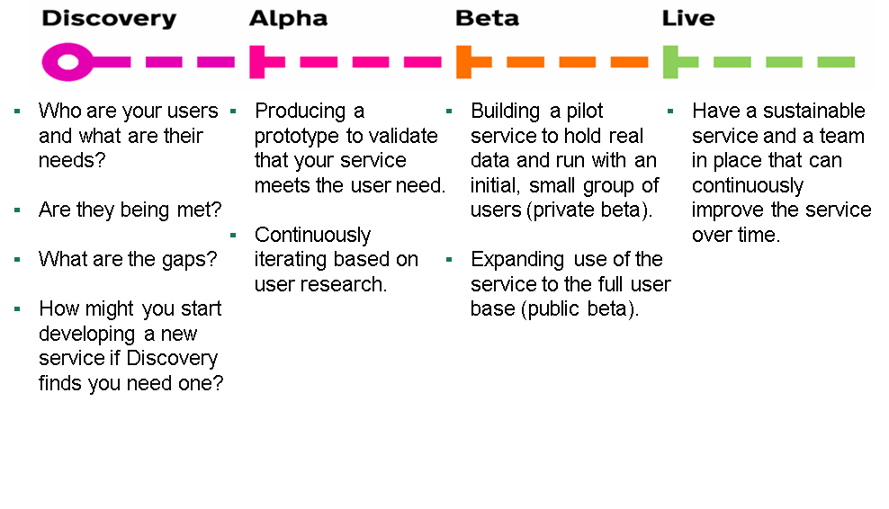

The Discovery that was commissioned by the DfT in 2017 carried out user research with all those that are involved with and interact with street and road works on the local road network. Several common themes emerged from the analysis around:

* a lack of consistent working practices, leading to overhead and discontent
* use of multiple systems leading to inconsistency
* the need for better communication and collaboration
* too much time and effort being spent managing inefficient processes
* a general lack of visibility and accuracy of limited data
* little or no support for collaboration and joint works
* use of outdated and expensive technology
* a lack of innovation.

The Discovery identified the goals for a new service and a set of prioritised user needs. It recommended that the project proceeded to an Alpha design phase to develop a new digital service that would enable a single source of accurate, up to date and open data on road and street works with the vision of:

Street Manager will be a new digital service that will transform the planning, management and communication of street and road works through open data and intelligent services to minimise disruption and improve journeys for the public.

The Alpha phase was carried out between November 2017 and February 2018. In this phase of the project, the DfT worked with users to build a prototype of the service and test it, design the service including the technical solution, and develop a full and evolving user backlog of user needs and personas to take into the Beta development phase.

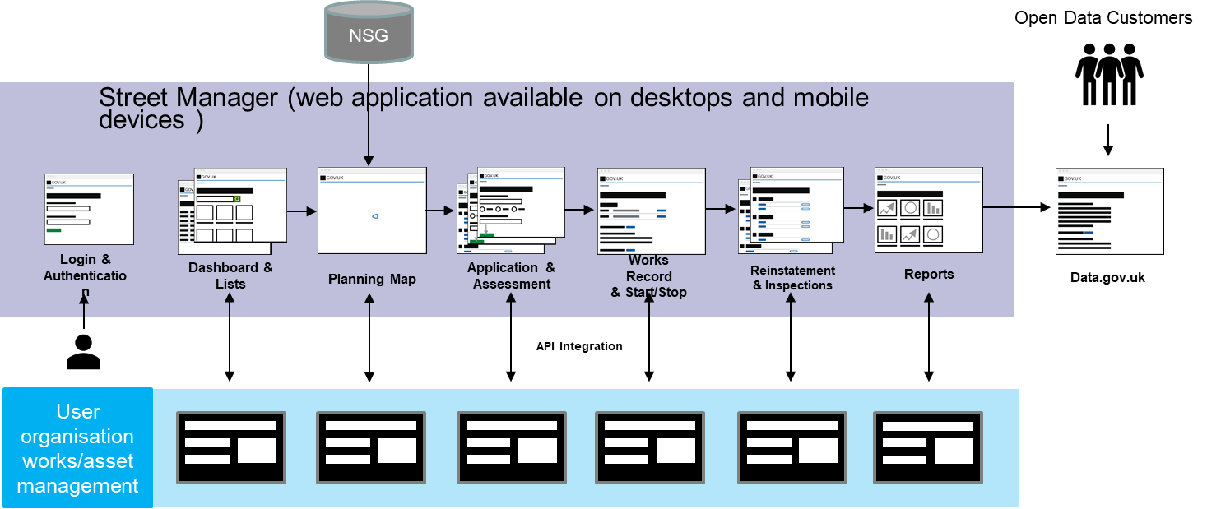The Alpha phase resulted in the service design below. Street Manager will be available via a website, [www.gov.uk/planandmanageroadworks](http://www.gov.uk/planandmanageroadworks), and will be accessible via desktops, laptops, tablets and mobile phones.

## 1.3 The Beta development phase

The objective of the Beta phase is to build a working version of the Street Manger service. The version being built must be able to handle real transactions and work at scale. The service must also continue to be improved in response to user feedback and testing to make sure it meets user needs.

The DfT began the Beta development in May 2018. It has been in private Beta between May and October 2019. It will be in public Beta from November to March 2020. The Street Manager service is now

* being tested with users. This is ongoing as new functionality is added;
* the technical infrastructure has been put in place, and is being fully tested and approved, including by the DfT’s digital service and architecture teams;
* it has met to date the Government’s Digital Service Standard. There will be a further Beta service assessment before public Beta. This is likely to take place in September 2019;
* it has been accredited in terms of security and tested prior to the start of private Beta. This work is ongoing and it will receive further accreditation and testing before public Beta;
* it will be available via gov.uk;
* updates and improvements into the development environment will continue. In line with the Service Standard, the DfT is committed to continuous service improvement;
* Key Performance Indicators (KPIs) are being put in place during private Beta to monitor performance and will be live from public Beta;
* the service is being tested for accessibility and will be accessibility audited during private Beta. This accreditation will be in place before public Beta;
* service levels and support are in place as well as disaster recovery plans and plans for when the service might be off-line;
* a data privacy impact assessment is in place and has been completed [to come in June 2019];
* [*if relevant* - APIs (Advanced Programming Interfaces) enabling data to be transferred with other works/asset management services are in place, have been tested, and are open];
* plans and a team are in place to continue user research;
* it will be assessed to ensure that it complies with accessibility needs;
* there is a prioritised list of work to be done to improve the service.

## 1.4 The DfT’s requirements

The Government will lay a Statutory Instrument amending the Regulations detailed in 1.2 above, requiring all local highway authorities in England and utility companies (statutory undertakers) to be using Street Manager by [*end date for transition*]. Users can either use Street Manager for planning and managing street and road works, or data can be submitted by an API from another system, or we can do a mixture of both.

The technical specification relating to the old EToN systems will be withdrawn on [*end date for transition*]. Any notices/permits etc submitted after this date will therefore need to be in Street Manager, whether they are entered via the user interface or via the API links with other asset management or works management systems.

The DfT has paid for the development of Street Manager and has invested £10 million. It now plans to charge local authorities and utility companies for the ongoing costs of managing the service. Charges will cover maintenance and service support as well as the continuous improvement aspect. The proposed charge for [*our organisation*] is likely to be around [*banding charge*] for the financial year 2020/2021. After that period, charges will be on a fair, transactional basis. Charges will be on a cost recovery basis and charged in arrears. The charge is per organisation, regardless of how many people access and use Street Manager or the data. Both local authorities and utility companies will pay the charge, and heavy users will pay more than light users.

Charges will begin from 1 April 2020.

## 1.5 Fit with wider strategic goals

Street Manager is leading the way in terms of innovation and new digital services. It fits with our own organisation’s goals for:

[*some suggestions*:

* move to digital services
* innovation
* better communication/customer service
* more collaboration
* better planned and managed works to reduce impacts on congestion
* better network management
* innovations in Intelligent Transport Systems/Connected and Autonomous Vehicles/use of data on other intelligent services
* open data
* strategic planning
* programme delivery eg of new connections
* any political aims/statements
* etc]

# Strategic Case

## 2.1 Strategic drivers for change

The strategic drivers for this investment are as follows:

* There are around 2.5 million road and street works carried out in England each year. The DfT estimates the cost of congestion from street works at £4.3 billion per year. [*add in any local statistics about congestion you may have]*
* The current systems used by local highway authorities and utility companies to manage road and street works are out-of-date and unfit for purpose. Better planning, data and open information can lead to more coordinated works, shorter durations and performance-based monitoring. For example, utility companies and contractors could be monitored in terms of how often they collaborate with other companies and do joint works, how well they meet quality targets (right-first-time reinstatements and low defect rates), how well they plan in advance and how often they incur fines. This would open the door to local authorities offering incentives, for example, discounts on permit fees, to be offered to those companies who do well. We can also compare the performance of their own contractors to ensure that they meet performance and quality targets. Better planning can lead to quicker access to the network.
* Everyone using a single digital service can lead to greater consistency, reduced administration overheads and work arounds. Future legislative amendments can be implemented once and at the same time for all organisations. Disputes can be reduced and minimised.
* There is growing demand from the public, journey planners, app developers and others for open, up-to-date and accurate data on planned and live road and street works. A better informed public/road users can reduce levels of congestion as they can avoid the works or travel at different times. It can reduce customer contacts and complaints. Data can also help local authorities manage the local road network more effectively.
* There is huge scope for efficiencies and better value for money to be gained. The DfT estimates that local authorities and utility companies spend £30-£40 million each year on running the EToN system. This includes licence charges, administration overheads associated with making the system work as well as it can and developing parallel systems and work-arounds to overcome issues. The current spend on software licences and overhead/administration can be significantly reduced, works can be planned much more effectively and data-driven decisions can lead to better network management overall.
* Levels of demand for new utility infrastructure, for example, housing development, [other local developments, HS2, etc] and the roll-out of broadband/full-fibre networks, mean that street works need to be effectively planned and coordinated. Systems are needed that are flexible and responsive to increasing levels of demand and to deliver other policy priorities such as improving connectivity in our area, our own housing targets, our own targets for new connections etc.

The main benefits of a new Street Manager digital service will be:

* A single source of accurate, up to date data on live and planned street and road works
  + It will be fully compliant with legislation, supporting on-street compliance, reducing overheads and conflicts
  + Decisions will be informed and supported by data
* It meets user needs
  + It will have an accessible, modern user interface
  + We will have the ability to respond quickly to changing needs, including as a result of legislation changes and scale/pace of development
  + The service will meet currently un-met needs, e.g. map-based forward planning, reporting and performance
* There will be visibility of all works on all roads for registered users of the service
  + Enabling and supporting forward planning, collaboration, strategic planning across boundaries and network management
  + Open data will lead to product development and innovation for road users and others, as well as better communication
* Reduced cost, improved administration, less duplication and no vendor lock-in.
* [*add in any strategic benefits specific to your organisation or local area]*

### Benefits

## 2.2 Issues with existing arrangements

The main system used by those working in the street works sector (the primary users) was originally developed in the 1990s. It is called the Electronic Transfer of Notifications or EToN. EToN comprises a common XML language backed by an XML schema and a set of rules for its operation and implementation in various software packages such as asset management systems used by local highway authorities (LHA) and contractors to manage the highways.

EToN has been updated over the years – version 6 is the current one in use. EToN allows for notices and permits to be submitted to the LHA, it will allow for 2-way communication between the LHA and the works promoter to, for example, query times and plans, and it will store details of the works.

Each EToN user (around 250+ LHA and utility organisations) has to have it’s own EToN product. The DfT estimates that LHAs alone are currently spending £6-7 million per year on these software licences and, in total, LHAs and utility companies are spending up to £40 million per year in licence costs, overheads, additional staff resource and in developing parallel systems and work-arounds to overcome issues.

[*add in any costs or issues specific to your organisation]*

The DfT owns and issues a detailed technical specification that provides the rules through which data is exchanged between EToN systems into which EToN has been integrated. The data requirements are also underpinned by regulations and guidance. It was last updated in 2013.

The Discovery carried out user research to understand whether the current approach met user needs and was cost effective and efficient, or whether it has become too inflexible, inefficient and costly. Research also considered what new systems might be required to meet the user needs identified.

In carrying out the research, the team spoke to a range of users via a range of techniques. Users were identified initially by a small group of representatives from authorities and utility companies. Other users were then identified as the discovery progressed. The survey was completed by attendees at a major street works conference.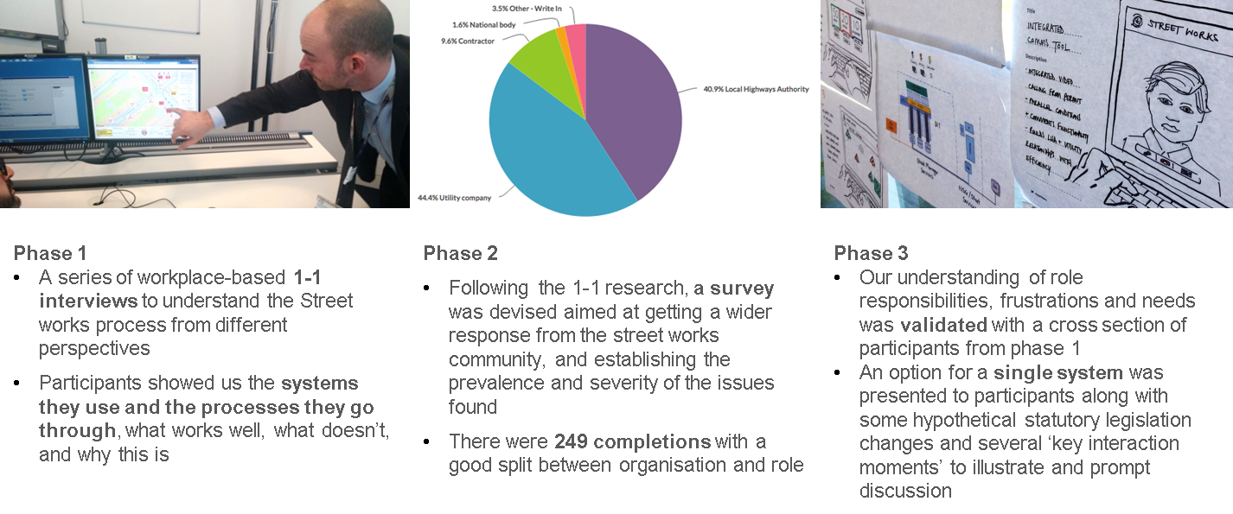

The discovery team had 1-1 sessions with

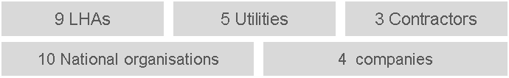

A summary of the issues found the Discovery team with the current situation is set out below. Several common themes emerged from the analysis around a lack of consistent working practices, the need for better communication and collaboration, too much time and effort being spent managing inefficient processes and a general lack of visibility and accuracy of limited data.

### Consistency and standardisation:

* The interpretation of regulations and guidance is inconsistent and this creates overhead and discontent.
* EToN does not always align well with legislation or the street works reality.
* Multiple EToN systems hinder the street works process.
* Users need multiple parallel systems to manage street works and this has overhead.

### Data transparency and accuracy

* The lack of data transparency and accuracy makes the street works journey more difficult / fragmented.
* Users have to go to different websites, internal and external systems to get a full picture but this picture is often incomplete or out of date.
* Most promoters simply work to the legal requirement of issuing start and stop notices by the end of the following day for planned works, creating an inaccurate real time picture of active street works.

### Speed and fluidity

* Speed and fluidity of the street works operations can be hindered by the high number of transactions taking place, many manual processes and limited mobile working.
* For LHAs, the many information systems that need manually checking and often limited mobile working slows the process down.
* For Utilities, there are often many different transactions, mostly manually assessed, as part of the permit process in their effort to increase compliance and reduce charges.

### Collaboration

* Promoters realise Collaboration is an important area – but the incentives are not always immediately obvious, it is not easy to see what works are being planned and it is difficult to arrange joint works.

### Innovation

* Existing arrangements do not make the most of modern technology and the opportunities that this offers.
* The time it takes to update and upgrade existing systems is a barrier to innovation.

### Data and technology

* EToN is an “Ecosystem” that consists of many distributed / interconnected IT systems. Each system is implemented differently, with different interpretations of the business logic and rules, and each covers a different functional scope.
* Integrations across the ecosystem are flawed. The functional specification, albeit detailed, is open for interpretation and non-absolute (more guidance than instruction). The ecosystem also contains a real mixture of high levels of integration with other “local” systems, and various disconnected IT systems.
* As an ecosystem it lacks standardisation, cohesion and transparency - with limited ability to change or evolve, or adopt the use of new and modern technologies without significant collaborative effort (and cost).

## 2.3 Business needs

The Discovery identified the goals for a new service and a set of prioritised user needs that were taken into the Alpha phase. User research continued through the Alpha phase with the following users.

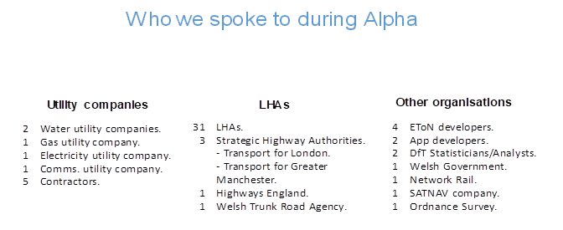

### Prioritised user needs

The Alpha phase identified the following key user needs:

* As a user, I need all organisations working on street and road works to have a **single view of work records**, so that there are fewer misunderstandings due to variations of work information.
* As a user, I need **consistent interpretation of the legislation** that applies the same standards for all organisations involved in street and road works, so that I can meet my legal obligations and reduce my costs.
* As a user, I need better **quality and consistent data**, so that I can produce and analyse reports and performance management information.
* As a user, I need works promoters from both LHAs and utility companies to **share forward plans**, so that I know about upcoming works, and so that I can coordinate or collaborate on a work.
* As a user, I need **near-to-real time updates** about work that could affect road users, so that I can help them to plan their journeys and reduce congestion.
* As a user, I need to **connect information together from different systems**, so that I can execute processes and avoid re-key.

The Street Manager project team also has a backlog (record of user stories) that is being taken forward during the Beta phase. Each part of the Street Manager service is being built to meet these needs. It will also be continuously improved so it will continue to meet user needs as the service develops.

### Key user personas

The Alpha phase has also resulted in a set of user personas that form the foundation of the user stories. These have continued to evolve in the Beta development phase. The service is designed to meet these key user needs.





### Additional user needs

* As a Street Works Inspector, I need to **know when there is a work to inspect** and where it is, so that I can check the work has been reinstated correctly.
* As a Compliance Manager, I need to be able to **view history of the works and ensure consistent interpretation of legislation, regulation and guidance**, so that I ensure standards are adhered and avoid fines.
* As an Agent/Supervisor, I need to be able to see **all permits/notices by ‘status’** and who is dealing with them, so that I can make sure works are being planned and managed correctly.
* As a Site Manager, I need to be able to see all works by status, with **accurate location coordinates**, so that I can manage delivery of works and ensure compliance.
* As a Network Manager, I need to have **visibility of all current and planned works and accurate, up-to-date information**, so that I can manage traffic on the network and communicate with road users.
* As a User of the Open Data, **I need up-to-date, accurate data** on live and planned works and their location so that I can develop a range of products for road users and others to use to plan their journeys.
* As a public sector worker, **I need access to and visibility of data on all works** so that I can analyse and track the impact of current policy and recommend options for further policy development that will meet the strategic aims of reducing the impact of works on congestion and improve people’s journeys.

## 2.4 Impact of not changing

The key risk associated with not changing is that the existing private sector developers who currently supply EToN systems could discontinue their support for ageing software, leading to a rise in prices, the closure of the service or a need to identify and migrate to other services.

The existing process for managing street and roadworks need to be modernised to meet the challenges of the next 20 years, including new intelligent transport systems, connected and autonomous vehicles, and growing demand for utility infrastructure.

The existing costs, inefficiencies and overheads associated with the current system would continue.

It will continue to be difficult to implement policy and process changes designed to reduce the impact of street and road works on congestion and improve people’s journeys. Any regulatory or policy change would need to be made through amendments to the EToN technical specification. The last change from v5 to v6 was in 2013. This took three years (from 2010) to discuss and agree the change and then a further four years for most users to upgrade their software.

The current frustrations, issues, costs and issues with EToN will continue if we do not change, and their needs will continue to be un-met.

*[Add in any organisation specific issues*]

## 2.5 Strategic options for delivery

[*Include here a discussion of options, e.g. use street manager user interface, use API links to your existing systems, or a mixture of both e.g. highways works teams using API, street works team using Street Manager, and note in the recommendation section below which option you plan to take.*

*Also note if these arrangements are proposed for Year 1, but might be revisited… or if these plans will stay in place for longer.*]

## 2.6 Recommendation

[*note your recommendation for how your organisation will integrate with Street Manager and the reasons for selecting this option. ]*

## 2.7 Risks of strategic option

[*note any key risks and mitigations from this options e.g. API development time. Reference a more detailed risks and issues log, either based on your organisation’s templates or the one provided by the Street Manager project*].

# Economic Case

## 3.1 Economic options and costs

[*Note here the different costs associated with the options included in section 2 above, and the cost associated with the option you have selected/recommended.*]

## 3.2 Cost of congestion from street works

[*The text included here is more suited to local authorities and local congestion benefits. Economic benefits for utility companies might include faster access to the network, delivery of wider strategic programmes in a more efficient way, better monitoring of contractor performance, reduced durations of works e.t.*c ]

There is considerable debate as to how much street works contribute to congestion and what cost this imposes on road users. The Halcrow Report (2004) has been used by the DfT to estimate congestion costs in the past. This estimates the cost of congestion to the UK from utility works at £4.3bn per year (2004 prices). This is calculated using a bottom up approach. The total duration of street works is estimated at 6.9 million work days and multiplied by the cost of congestion per work per day. Halcrow estimates the cost of congestion per work to be between £355 for small works on rural roads and £25,000 per day for large works on congested urban roads. This is estimated using model outputs including QUADRO, a Highways England tool. Inflating this figure to 2017 prices gives an estimated cost of congestion at £5.6bn per year. This includes only the time cost of congestion.

Since street manager will apply initially only to England and will apply to both street works and road works, the Halcrow cost of congestion must be adjusted. The total cost of congestion from street works are increased to include road work from local authorities (LAs). The assumption that two thirds of road works are completed by utilities and one third by LAs is used. This is sourced from one local authority and industry knowledge. The total cost of congestion due to road works in the UK is reduced, based on population data, to factor in works in England. This gives an estimated cost per year of £7bn.

*[add in any local data you might have on congestion costs]*

## 3.3 Benefits identification

[*Note any organisation specific benefits from use of Street Manager. The text below highlights some examples but tailor this section as appropriate.*]

The main economic benefits that result from better managed and coordinated street works and national, regional and local level are reductions in congestion costs.

Street manager could result in fewer works as there would be more coordinated and joint works. Durations could be reduced as street manager would enable data-driven decisions, impact assessments and better planning. Data would enable reporting and performance management, opening the door for performance-based incentives, improvement plans and risk-based inspections. Data on live and planned works could reduce congestion as an informed travelling public could avoid the site or travel at different times.

Due to lack of evidence on the reduction in duration of road works from Street Manager, illustrative scenarios are shown in the table below at a national level. If, for example, street manager reduced the duration of road works by as little as 0.05% this would save a total of 4,000 road work days per year, with congestion savings of £3.5 million per year. At the higher end, if duration was reduced by 0.15%, congestion savings would equal £10.5 million per year.

|  |  |  |  |
| --- | --- | --- | --- |
| Reduction in duration | 0.05% | 0.10% | 0.15% |
| Road work days saved | 4,000 | 9,000 | 13,000 |
| Congestion savings | £3,514,000 | £7,020,000 | £10,542,000 |

The Halcrow estimate of congestion cost of £7bn includes only time cost. There are other benefits of reduced congestion. These include:

* Accident benefits from lower number of accidents at road works. Reducing the time delay at road works will reduce the number of accidents that tend to occur around road works due to the reduced total number of work days.
* Environmental benefits from lower emissions. By reducing the congestion arising at road works sites, street manager has the potential to reduce road transport-related emissions – particularly local air quality pollution that is exacerbated by stationary or slow, stop-start traffic.

The strategic case also identifies other benefits that could be delivered by street manager.

## Value for Money

[*Note here the annual costs vs any benefits that can be quantified. If possible, calculate a BCR.*

*Quantifiable benefits may include*

* Congestion savings
* Reductions in costs associated with existing systems. May not materialise in Year 1 but might materialise in Years 2 and subsequently.
* Savings in future upgrade costs. Street Manager charges include all future upgrades and changes, so there will be no additional cost for these
* Reductions in overheads – IT support, training on older legacy systems
* Do you lose permit fees from any permits that are deemed when existing systems are unavailable?
* Street Manager will be open for use by anyone in your organisations i.e. network managers, analysts, planning teams, HS2 coordinators etc. There may be savings in existing licence fees that are levied per user.
* No need to pay for unused functionality. Some products have to be licensed as a package so you currently pay for extras you may not use.
* Street Manager will act as the street works register – any savings here? Easier fulfilment of FOI requests for instance?
* Any time savings e.g. Street Manager can support regular coordination meetings, comms with stakeholders, reduced customer contacts, reductions in errors/tooing and froing correcting information in permits, location errors etc
* Ease of integration with other systems may reduce costs.
* No need for local hardware if using Street Manager user interface.

*Costs might include*

* DfT charge for Street Manager
* API integrations – build and then ongoing use
* Licence fees/charges for continued use of existing EToN products or asset/works manager systems. Identify costs associated with Street Manager only – there is a need for other products to continue other services e.g. highways activities, reporting etc but these will continue and are not materialising as a result from street manager
* One-off specific transition/change costs]

## Limitations and Analytical Assurance

[*Note any in this* section]

# Commercial case

Resources to carry out the Discovery, Alpha and Beta phases have already been procured by the DfT through the Digital Outcomes and Specialist (DOS) Framework available through the GOV.UK Digital Marketplace. A competitive procurement for the Alpha and Beta phases was carried out between September and November 2017. The contract allowed DfT to proceed to the Beta phase with the same contractors. Individual statement of works for each phase of the project are detailed and form part of the overall contract. DfT procurement colleagues and business partners have overseen this process.

The DfT will contract through competitive procurement a contractor to provide ongoing support for Street Manager from April 2020. The contractor will also provide service support and will continuously improve the service based on user needs. The route to market will be through the DOS Framework. Access to and use of the Government’s Digital Marketplace and catalogue ensures competitive prices and efficiencies of scale. The contract will be let for a period of 2 years.

The DfT will also procure cloud services, initially via Amazon Web Services, but this will continue to be reviewed from time to time to ensure best value for money.

[*Include additional details for any existing contracts and arrangements for any systems you plan to continue using and linking to Street Manager via an API, including procurement routes and contractual timescales.* ]

## 4.1 Required products and services

[*Detail here which products and services you need to deliver Street Manager within your organisation.*]

# Financial case

## 5.1 Financial appraisal

The estimated total cost for [*name of* organisation] for use of Street Manager will be approximately £xxxxxx. This will be payable in the financial years 2020/21 and will be ongoing. The costs can be broken down as follows:

* [*Detail the costs associated with Street Manager for your organisation. See section 3.4 above*]

[*Include a table breaking down annual costs identified]*

## 5.2 Affordability

[*Include information on which budget will cover this outlay. Note if these can be recovered in any way e.g. from permit fees.*]

# Management case

The following arrangements are being put in place from 1 April 2020 to ensure continued successful delivery and governance of Street Manager.

## 6.1 Timetable

The transition date for Street Manager is [*transition*]

[*Include information about your organisation’s transition plans* ]

From [*date*], our organisation will have implemented Street Manager. Charges will begin on 1 April 2020.

The DfT will continue to manage the service and will continue to provide staff resource in the form of service owner, product owner and input as needed from digital service and architecture experts.

Street Manager will continue to use the Agile project management methodology, in accordance with the Government Digital Service’s service manual.

## 6.2 Ongoing governance

The DfT is working with Street Works UK and the Joint Authorities Group to put in place governance arrangements from 1 April 2020. These arrangements will inform the continued development and improvement of Street Manager and will oversee spend on behalf of all users.

Our organisation will also be able to input into these discussions via the open forums which DfT is using to communicate with users, and via [*note any involvement you may have including regional HAUCs, local JAGs, user research etc*]

## 6.3 Milestones

The high level delivery plan is as follows:

[*Include key milestones and timelines for your transition. Use the roadmaps and the plans provided by the Street Manager project to flesh out this section.*]

## 6.4 Key issues, risks and risk management

The top issues and risks to the project and associated risk management are:

[*note the key risks, issues and mitigations from your risk register. You may have your own templates within your organisation or you can use the one sent out by the Street Manager project]*

A full risk register and issues log is maintained.